
Flexflow Tier-2 ACN Product Transformation

Record of Release

Version No. | Modified By | Reviewed By | Authorized By | Release Date | Modification Done
1.0 | Saravanakumar Jeyaraj |  |  |  | Document creation

Table of Contents

Record of Release 2
1. Introduction 4
2. Flow Diagram 4
3. MFT Logic 5
4. Column Mapping 5
5. Load Product 5
6. Product Transformation 6
7. Publish 6

Introduction
This document provides a comprehensive guide to the product transformation and publishing process, including MFT logic, column mappings, product transformation, and publishing using Databricks. The process ensures reliable and automated handling of files and job executions.

Details of the utilized storage account and Databricks workspace are provided below:
 | Development Environment | Production Environment
Storage Account | sa01flexflowtp01dev | sa01flexflowtp01prod
Databricks Workspace | databricks-cdl-flexflow-tp-dev-01 | databricks-cdl-flexflow-tp-prod-01
Schema/Catalog | cdl_tp_dev.gold_tp | cdl_tp_prod.gold_tp
Service principle | az-sp-cdl-flexflow-tp-01-dev | az-sp-cdl-flexflow-tp-01-prod

Flow Diagram
Workflow: Tier2_ACN_Prod
Here's a brief explanation of the flow diagram based on its main components:
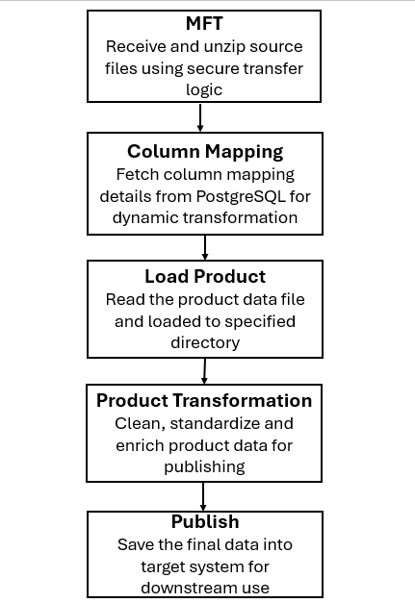

2.i) MFT Logic
Purpose: MFT Logic handles the secure and automated file movement.
Folder path: ‘/mnt/tp-source-data/WORK’
Description:
Step 1: Listing files from a specified directory.
Step 2: Checking for ZIP files related to a specific RUN_ID.
Step 3: Creates a directory for the file if it does not exist and returns the directory name.
Step 4: Unzipped at the given local path and extracted to the specified directory.
Step 5: Check if the given directory contains any subdirectories. If it does, copy the files from those subdirectories to the destination directory.
.

2.ii) Column Mapping
Purpose: Mapping source data columns to target schema.
Description:
Step 1: Extract column mapping data from a PostgreSQL table(cdl_tp_dev.mm_col_asign_lkp).
Step 2: Filter the Data Frame based on a specific contract ID.
Step 3: Save the filtered Data Frame as a Parquet file within the designated directory.

2. iii) Load Product
Purpose: Read the product data file and load to specified directory.
Description:
Step 1: The system processes external data files based on the specified file type, such as 'fact', 'prod' or ‘mkt'.
Step 2: ZIP files are extracted to access the enclosed data files.
Step 3: The system performs data transformations, including column renaming and filtering operations.
Step 4: File-type-specific logic is applied to customize the processing steps according to the data category.
Step 5: The transformed data is saved in Parquet format for optimized storage and performance.

2.iv) Product Transformation
Purpose: Ensure clean, consistent, and enriched product data for accurate downstream processing.
Description:
Step 1: Removes duplicate records and null values from the Data Frame to maintain data integrity and ensure consistency.
Step 2: Aggregate the Product Data and Grouping by Category.
Step 3: Standardize the product data and add the key columns RUN_ID and srce_sys_id.
Step 4: Assign a Product SKID.

2.v) Publish
Purpose: Final transformed product data is published to the target systems.
Directory: ‘/mnt tp-publish-data/ACN_Prod_Load/{RUN_ID}/ACN_Prod_Load_chain/’
Description:
Step 1: Read file from a specified directory.
Step 2: Acquire the semaphore to initiate the current run and prevent parallel executions
Step 3: Check for existing data in the target table using unique identifiers (e.g., srce_sys_id, prod_skid):
- If matching records exist, perform an update to reflect the latest changes.
- If no matching records exist, insert new records into the table.
Step 4: Once data operations are completed successfully, release the semaphore to allow subsequent processes or runs to proceed.
Step 5: Call the cdl_publishing function with the defined parameters.
Step 6: Archives the processed file by relocating it from the working directory to the designated archive directory.

